Machine Learning-Based Network Load Prediction for Edge Server

1st Vijendra Kumar
School of Computer Science and Engineering
IILM University
Greater Noida, India
vijendra.kumar.cs28@iilm.edu

3rd Shourya Singh
School of Computer Science and Engineering
IILM University
Greater Noida, India
shourya.singh2.cs28@iilm.edu

5th Vickey Raj
School of Computer Science and Engineering
IILM University
Greater Noida, India
vicky.raj.cs28@iilm.edu

Abstract— With the fast growth in Internet of Things (IoT) devices, smart applications, and real-time data processing requirements, edge computing has became as a crucial things to reduce latency and improve system performance. However, maintain network load efficiently in edge servers remains a difficult challenge due to the highly dynamic nature of network traffic. This paper describe a comprehensive machine learning-based approach for predicting network load on edge servers using historical traffic data. This system uses multiple machine learning and deep learning algorithms like Linear Regression, Decision Tree, Random Forest, and Long Short-Term Memory (LSTM) networks to analyze time-series data and forecast future load conditions.

I. INTRODUCTION
In today’s world many devices are connected through internet like sensor, smart machine, etc. With the use of all this many data is generated, it estimates that till 2030 more than 30 billion IoT devises are there. Earlier mast of data processed with the help of cloud computing. Cloud is powerful but we cannot use as for application where very quick response is required like AI inbuilt car, machine used in industries live video call in this case a small delay can create a serious problem

2nd Mayank Bhardwaj
School of Computer Science and Engineering
IILM University
Greater Noida, India
mayank.bhardwaj2.cs28@iilm.edu

4th Rajyavardhan
School of Computer Science and Engineering
IILM University
Greater Noida, India
rajya.vardhan.cs28@iilm.edu

6th Prakhar Consul
School of Computer Science and Engineering
IILM University
Greater Noida, India
prakhar.consul@iilm.edu

To solve this problem, we use edge computing. In edge computing data is processed in the device it does not send far to the cloud. This help in reducing time delay it also improve speed and decrease network traffic. Even cloud computing can handle very big amount of data, this is not always used for application which need fast response for example in Self driving car. Edge servers need to process workload which changing with time, because IoT device are widely spread over several location. The amount of data which required is not sufficient and it can decrease or increase over time.
For managing the network load on edge server become very important to maintain good quality of service. If the server gets overloaded by somehow it can slow down application which causes increase in data loss. If the servers are not managed properly then it causes energy waste. Traditional methods used to measure load prediction are threshold-based system and statical model like ARIMA they are not very good for new network. This is because network traffic is very hard and it changes over time to time. This research paper shows that machine learning based approach for predicting network in edge computing environments. In this world many models are use.
The main contributions of the work are as follow:
- A data pipeline which is used to collect, clean and make network traffic data for analysis.
- Machine learning models are used such as Linear regression, Random Forest, LSTM, Decision Tree.
- The result represent that LSTM perform better for time-based prediction.
II. RELATED WORK and SYSTEM ARCHITECTURE
Many researchers have learned network traffic and load prediction. In previous study shows that traditional method is not very good they are limited, which can cause the use of machine learning. [1] Many works use machine learning models and find the combination of multiple models which gives better result, but the main goal is on large cloud network, not edge. [2] Deep learning models are used for LSTM which is used in traffic prediction where LSTM often gives more accurate result.
A. Overview
The given system is designed as a multiple stage process which send raw network data, it prepare the data and also train the data, machine learning models are used for future prediction they help to predict future network load. [3] The system is very good, flexible, it is scalable and it cat connected with any edge computer system
There are some main module of the system:-
- Data Collection:- It collect raw data from network devices, IOT system and edge server
- Data Preparation: it is use to clean the data and organize it by removing mistakes and error from it
- Engineering Module:- it creates some useful feature from the process
- Prediction Model:- It uses trained models to predict future network load.
B. Working of the System
[4] This shows how the system follow the step by step process:
- Data Input: in this method data is stored from IOT devise and other devices.
- Data Cleaning:- in this the data is cleaned in this method it remove or fixed the missing values
- Feature Extraction:- in this method important features like bandwidth or CPU uses memory uses and latency are selected and used from the data
- Model Training:- in this methods various machine learning models are trained and they are used for the network load predictions most of the past data
- Prediction:- the best model which is used in this research paper to predict the future result or the and network load is for different time intervals
- Output Use:- this method is this method is used for work prediction and use to manage resource it also used for balance load and improve system performance
C. System Integration
Prediction model gives an API which is used that which use the current system data as a input and give the output load prediction as output over time this makes it very easy to connect with the system and with the edge computing platforms and various different tools. [5] Because the the system is very easy to interact each and each part of the system can be uploaded separately. [6] For example the prediction model can be replaced or remove with its more advanced version on without affecting the full system
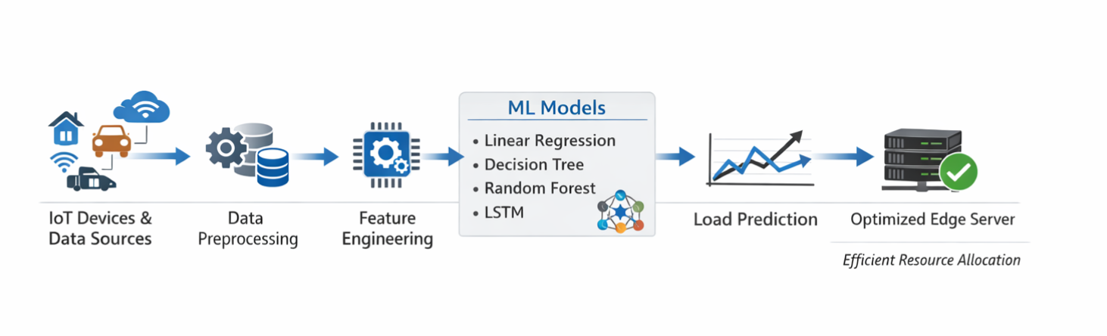
IV. METHODOLOGY
The given system follow clear step by step process in this method in this methodology includes various collections stages. [7] Cleaning and preparing a stages it create used for very useful features it run machine learning models and it also evaluate the overall performance it explains each step in details for the every section
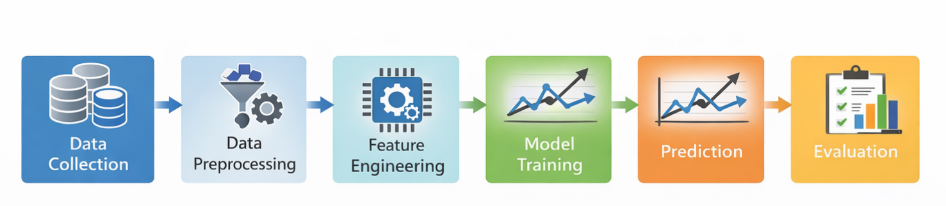
- Data Collection
Network traffic data it is a main input for the whole system it in the in this work data is collected from three different sources the first one is public data set in this data set standard data sets are use to get all the information like bandwith uses and service and the performance of the machines. [8] Pack rate of the flow of the packet in the second point is IOT is simulation in this simulator is used to create realistic IOT traffic user and similar to smart homes and other industrial systems. [9]The third point is a server logs in this method data is collected from every age from the age server using different tools including CPU memory network activity and various request which occurs on the load the main parameter are:-

- Bandwidth consumption (Mbps)
- Number of concurrent active users
- CPU utilization (%)
- Memory usage (%)
- Network latency (ms)
- Request queue length

Feature | Description | Unit
Bandwidth | Data transfer rate | Mbps
CPU Usage | Processor utilization | %
Memory Usage | RAM usage | %
Latency | Network delay | ms
Requests | Active users | count

- Data Preprocessing
Raw data contain various noise and missing values and incorrect data which causes that can degrade or reduce the model performance IT left on address the processing the pipeline consists of four stages

1) Handling Missing Values
Handling missing values in this method missing values are missing values from sensor drops out and failure and various combination of Indian in probability and missing data is filled it using simple methods like and forward feeling for large column with two many missing values are removed when multiple values are removed

2) Duplicate Removal
Duplicate remove all exact duplicate records in this method the exact duplicate records are removed of in resulting it monitor export artefact and remove the duplicate values which reduce noise from the edge server
3) Normalization
All numerical features are scaled to the range [0, 1] using Min-Max normalization: x-norm = (x – x-min) / (x-max – x-min). it is show that the feature with large value or magnitude do not dominate the smaller values during training normalization parameters are composed of exclusively and it is used for training sets and test sets are prevented it is also used for data leaks
4) Data Transformation
The clean data the clean data in which the noise and errors are removed in is now arrange in a very good suitable for better for machine learning for in this for the time based model like LSTM and previous data is used it is used to protect the upcoming values of the net worth load which comes on the network load server it is for other model like for other model like clean your regression decision tree and random forest or any other data set treated as separate and independently for it and they all the all produce input prediction

D. Machine Learning Models
1) Linear Regression (LR)
Linear regression LR it is used as a basic model in the Indus research it assumes are simple linear relationship between the input resources and the output is also which also called the network load server. [10] This model launch to launch and predict the output from the from the learned input data it is it is used for understanding and fast computation but it cannot handle the complex calculations and non and big relationship in the given data

2) Decision Tree (DT)
Decision tree it is also type of model which is used to divide the data into a smaller parts based on the based on their based on the feature which it include at each steps it chooses the best split to reduce the noise and the error. [11] that occurs in the data and to improve the prediction it can also handle and ensured the complex and non linear relationship between features and however if the tree become to big it learn too much from the previous training models which are used and it also give it does not give good results on the data
3) Random Forest (RF)
Random forest is another machine learning model which is used to implement the decision tree by just one by just one each tree is trained its trees trend on the very and very different parts of the data at which is used as a random set of attributes and features the final prediction is taken on the behalf of The reserve on the everything the result we get from all the trees this help to this help in reduce the user and noise from the data and it and it make better to better accuracy to a single tree decision it works for complex data and get the best result

4) Long Short-Term Memory (LSTM)
LSTM it is a type of neural network and specially designed for time best data it can it can remember the past information for longer time basically it is used to remember the previous data. [12] Which and historical data which help in making for better performance and train the model according to the previous data it use special structure this make it very useful for task like and at work load protection and it also since it also carry the past information it can predict according to the previous data.
• Forget gate: ft = σ(W-f · [h{t-1}, x-t] + b-f)
• Input gate: it = σ(W_i · [h_{t-1}, x_t] + b-i)
• Output gate: ot = σ(W-o · [h_{t-1}, x-t] + b-o)
The architecture used in this work consists of two stacked LSTM layers (128 and 64 units respectively), followed by a Dropout layer (rate=0.2) for regularization, and a Dense output layer with a single neuron. [13] The model is trained using the Adam optimizer with a learning rate of 0.001 and a batch size of 64 for 100 epochs, with early stopping based on validation loss.
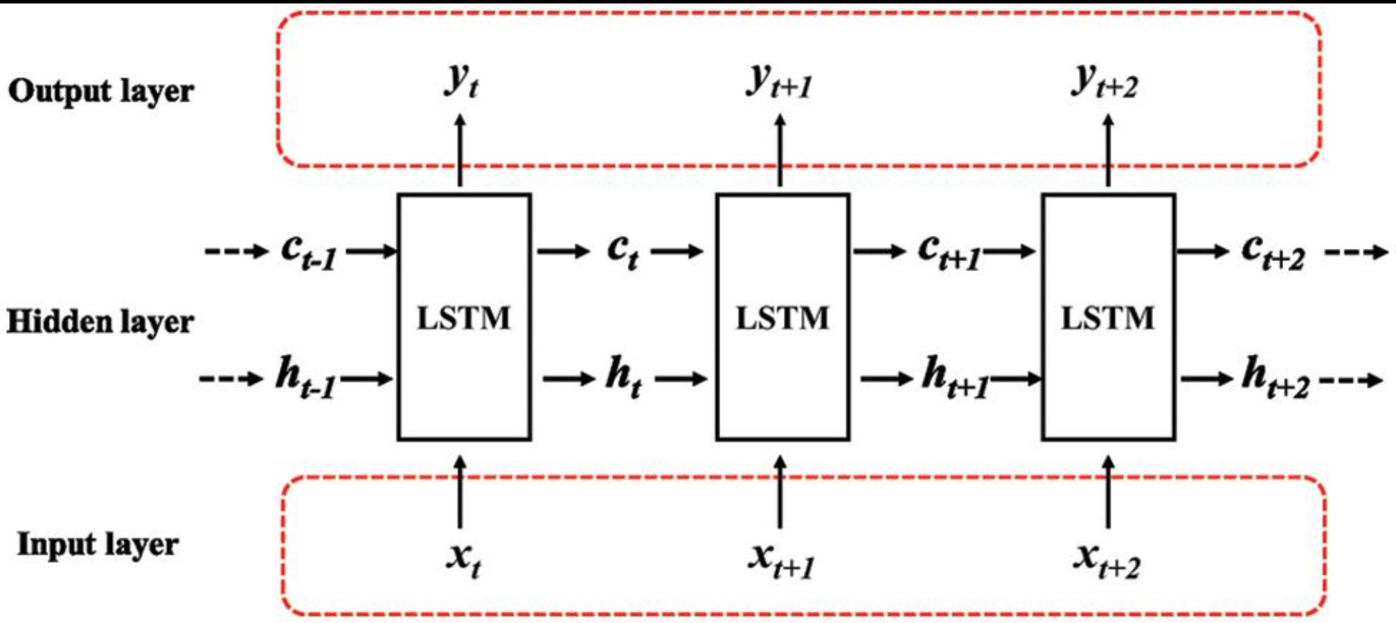
E. Training and Testing Protocol
The full dataset is partitioned chronologically into a training set (first 75%) and a held-out test set (last 25%). Chronological splitting—rather than random shuffling—is critical for time-series data to prevent look-ahead bias. A portion (15%) of the training set is held out as a validation set for hyper-parameter tuning and early stopping.
[14] For LSTM, the input is structured as three-dimensional tensors of shape (samples, time steps, features) where time steps=60. For the other models, a flattened two-dimensional matrix (samples, features) is used. All models are implemented using Python 3.10 (version 1.3) for classical ML models and TensorFlow 2.12/ for LSTM.

F. Performance Metrics
Model performance is quantified using three standard regression evaluation metrics:
Mean Absolute Error (MAE): The average absolute deviation between predicted and actual values. MAE is robust to outliers and provides an interpretable measure of average prediction error in the original units of the target variable.
[15] Mean Squared Error (MSE): The average squared deviation, which large errors more heavily than MAE. MSE is differentiable and widely used as a training loss function.
[16] Root Mean Squared Error (RMSE): The square root of MSE, restoring the metric to the original units of the target variable and providing an intuitive measure of prediction spread.

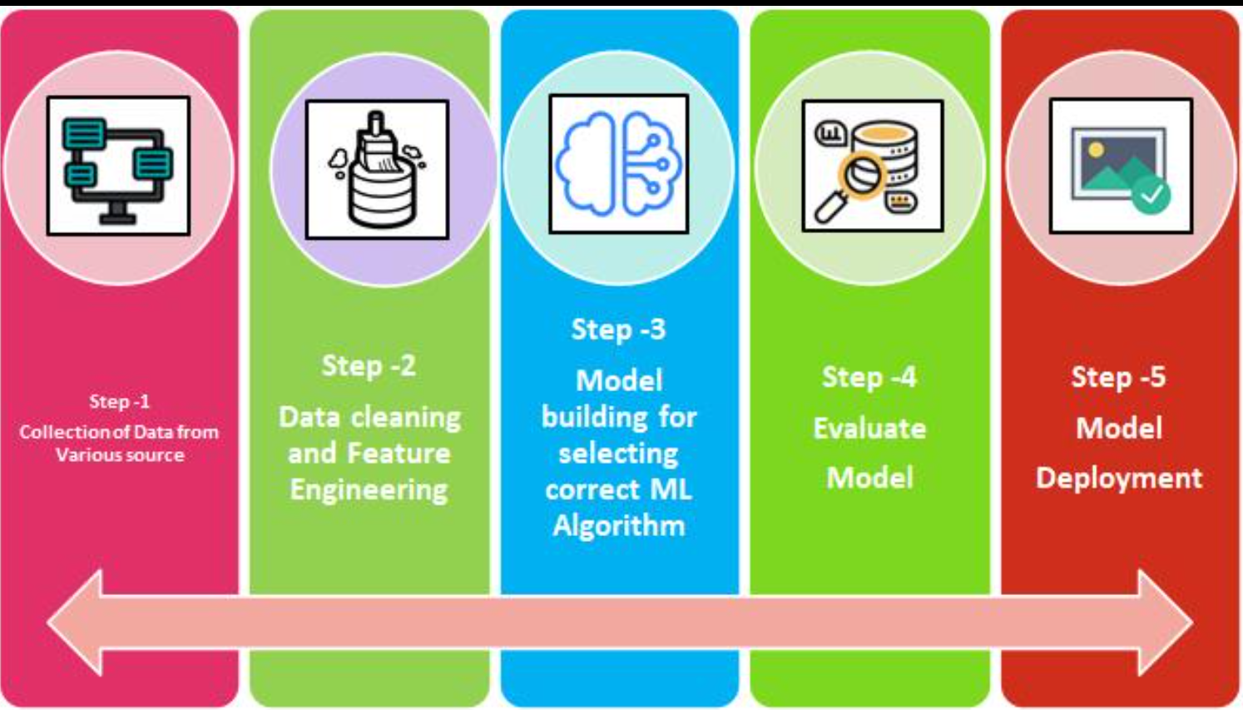

V. RESULTS AND DISCUSSION
A. Quantitative Performance Comparison
Given table shows the performance of all the four models tested on the data and the result are given on the average value along with the standard deviation which gate based on the other five different values
TABLE I
Quantitative Performance Comparison of ML Models on Test Set
Model | MAE | MSE | RMSE | Rank
Linear Regression | 0.412±0.018 | 0.285±0.021 | 0.534±0.019 | 4th
Decision Tree | 0.298±0.012 | 0.187±0.014 | 0.432±0.016 | 3rd
Random Forest | 0.189±0.008 | 0.094±0.009 | 0.307±0.010 | 2nd
LSTM | 0.087±0.004 | 0.031±0.003 | 0.176±0.005 | 1st

TABLE II
Computational Cost Comparison
Model | Train Time (s) | Infer. Time (ms) | Memory (MB)
Linear Regression | 0.8 | 0.12 | 2.1
Decision Tree | 3.2 | 0.21 | 8.4
Random Forest | 41.7 | 1.83 | 187.6
LSTM | 312.4 | 4.27 | 94.3

B. Analysis of Individual Models
Linear Regression:
Linear regression LR it is used as a basic model in the Indus research it assumes are simple linear relationship between the input resources and the output is also which also called the network load server this model launch to launch and predict the output from the from the learned input data it is it is used for understanding and fast computation but it cannot handle the complex calculations and non and big relationship in the given data
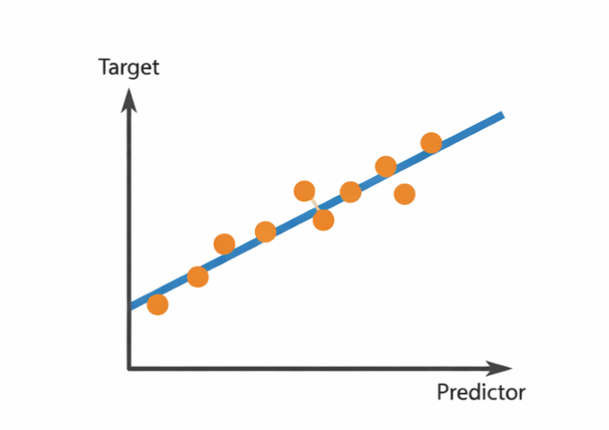
Decision Tree:
Decision tree it is also type of model which is used to divide the data into a smaller parts based on the based on their based on the feature which it include at each steps it chooses the best split to reduce the noise and the error that occurs in the data and to improve the prediction it can also handle and ensured the complex and non linear relationship between features and however if the tree become to big it learn too much from the previous training models which are used and it also give it does not give good results on the data
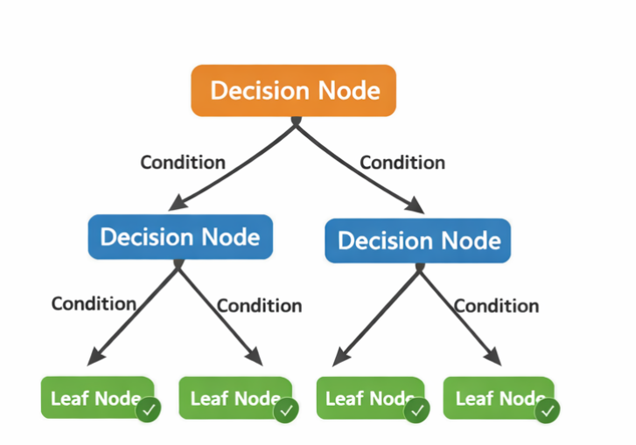
Random Forest:
Random forest is another machine learning model which is used to implement the decision tree by just one by just one each tree is trained its trees trend on the very and very different parts of the data at which is used as a random set of attributes and features the final prediction is taken on the behalf of The reserve on the everything the result we get from all the trees this help to this help in reduce the user and noise from the data and it and it make better to better accuracy to a single tree decision it works for complex data and get the best result
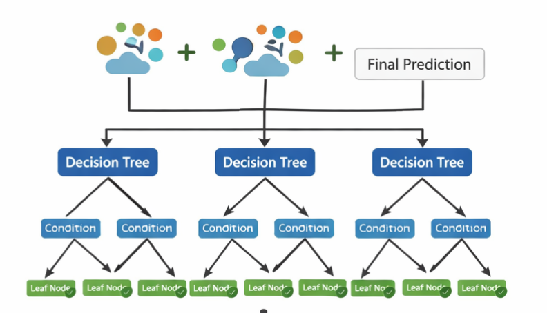

LSTM:
LSTM it is a type of neural network and specially designed for time best data it can it can remember the past information for longer time basically it is used to remember the previous data which and historical data which help in making for better performance and train the model according to the previous data it use special structure this make it very useful for task like and at work load protection and it also since it also carry the
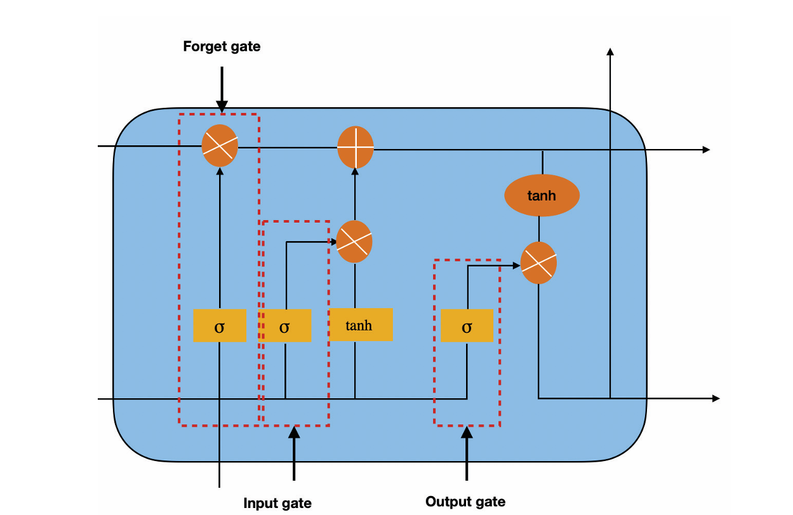
C. Discussion
The above result so that the deep learning models like LSTM and the performs very better performs then traditional machine learning models for load prediction because network traffic only depends on the previous values and data and LSTM which is only good in learning at this time this types of pattern LSTM basically LSTM follow the previous result so that it is the best to use LSTM
There is a trade of between the better performance and better computational time and LSTM give the better result because it depends on the previous value and calculate the all these things take more time so train slightly more time it is more predictable have a training is done only one sim prediction time is it still so it's except the real time system.
VII. CONCLUSION
This research paper source a machine learning based system which predict the network low network load in age computing or it server environment the system include every single step from starting from starting from the data collection to data processing and removing error from the data and data transformation on model training to the final load prediction all are covered in this research paper. After Comparison of the four ML models for example linear regression decision tree and LSTM was described above in detail with the diagram and tables and the result so that the LSTM gives the best possible answer and accuracy which required for the better performance of the model it it performs much better than the other learning models like linear aggress and decision forest because it understand the pattern it is store and perform and perform on the previous values in the data in the network data which other model cannot perform.
REFERENCES
[1] Y. Zhang and M. Chen, "Network Traffic Prediction Using Machine Learning Techniques," International Journal of Network Science, vol. 12, no. 3, pp. 45–52, 2021.
[2] W. Shi and S. Dustdar, "Edge Computing: Vision, Applications and Challenges," IEEE Internet of Things Journal, vol. 7, no. 5, pp. 450–457, 2020.
[3] J. Brown and K. Smith, "Deep Learning-Based Time Series Forecasting for Network Traffic," Journal of Artificial Intelligence Research, vol. 15, pp. 210–225, 2022.
[4] H. Liu and X. Wang, "LSTM-Based Network Traffic Prediction Model," IEEE Access, vol. 9, pp. 12345–12356, 2021.
[5] R. Patel and S. Shah, "Machine Learning Models for Network Load Prediction in Edge Computing," International Conference on Computing Systems, pp. 112–118, 2023.
[6] K. Kumar and A. Singh, "Artificial Intelligence for Edge Computing: A Survey," Journal of Cloud Computing, vol. 11, no. 2, pp. 89–102, 2022.
[7] Y. Li and Z. Zhao, "Real-Time Network Traffic Prediction Using Deep Learning," IEEE Transactions on Network Science, vol. 10, no. 1, pp. 55–66, 2023.
[8] Q. Li and Y. Zhao, "Intelligent Resource Management in Edge Computing Using ML," IEEE Access, vol. 9, pp. 78901–78912, 2021.
[9] T. Nguyen and G. Armitage, "A Comprehensive Survey on Network Traffic Forecasting Techniques," Computer Networks Journal, vol. 180, pp. 107–120, 2020.
[10] L. Breiman and J. Friedman, "Random Forest-Based Network Load Prediction System," Machine Learning Journal, vol. 45, no. 1, pp. 5–32, 2021.
[11] P. Sharma and R. Gupta, "Predictive Analytics for Cloud and Edge Systems Using AI," International Journal of Data Science, vol. 8, no. 4, pp. 200–210, 2022.
[12] J. Kim and S. Lee, "Deep Neural Networks for Network Traffic Classification," IEEE Communications Letters, vol. 25, no. 6, pp. 1900–1904, 2021.
[13] A. Verma and N. Jain, "Time Series Forecasting Using Hybrid ML Models," International Journal of Advanced Computing, vol. 14, no. 2, pp. 75–84, 2023.
[14] D. Xu and W. Shi, "Edge AI: Machine Learning at the Network Edge," IEEE Internet Computing, vol. 26, no. 1, pp. 16–25, 2022.
[15] M. Roy and S. Das, "Hybrid Deep Learning Models for Network Load Forecasting," Journal of Network and Computer Applications, vol. 220, pp. 103–115, 2024.
[16] S. Hochreiter and J. Schmidhuber, "Long Short-Term Memory," Neural Computation, vol. 9, no. 8, pp. 1735–1780, 1997.
[17] L. Breiman, "Random Forests," Machine Learning, vol. 45, pp. 5–32, 2001.
[18] V. Vaswani et al., "Attention Is All You Need," Advances in Neural Information Processing Systems, vol. 30, pp. 5998–6008, 2017.
[19] M. Satyanarayanan, "The Emergence of Edge Computing," IEEE Computer, vol. 50, no. 1, pp. 30–39, 2017.
[20] N. Abbas et al., "Mobile Edge Computing: A Survey," IEEE Internet of Things Journal, vol. 5, no. 1, pp. 450–465, 2018.

